Statistical Analysis of Covid 19 Hospitalizations in France
Nicholas Carlson, Alex Toon, Divya Reddy Konda
INFO-B518 APLD STAT MTD BIOMED INFORMTCS

Abstract
This project analyzes COVID-19 hospitalization patterns in France using a publicly available dataset containing daily national-level indicators. The purpose of this analysis is to examine how hospitalization burden evolved throughout major pandemic waves and determine whether new hospital admissions are statistically related to overall hospital occupancy. The dataset includes national daily counts of hospitalized patients, ICU patients, deaths, recoveries, and new admissions. Data preprocessing involved filtering to national values, converting numerical fields, and checking for missing values.
Descriptive results showed multi-wave patterns in overall hospital burden, with clear increases in hospitalizations occurring during late 2020 and early 2021. Inferential statistical analysis included a Pearson correlation test and a simple linear regression model. Results showed a strong positive association between new hospital admissions and total hospitalized patients (r = 0.70, p < .001). Regression analysis indicated that new admissions significantly predicted hospital burden (B = 7.82, p < .001), explaining about 49% of the variability in hospitalizations. The mean daily hospitalization count was estimated at 17,148 patients, with a 95% confidence interval of [16,413, 17,883]. These findings suggest that surges in new admissions are closely followed by increased hospitalization levels. This analysis demonstrates the usefulness of basic statistical tools in evaluating real-world public health trends and highlights opportunities for future work involving regional and ICU-specific comparisons.
Introduction
Understanding COVID-19 hospitalization patterns is important because the number of hospitalized patients and ICU occupancy were primary indicators used by governments to assess pandemic severity and allocate resources. France experienced multiple infection waves between early 2020 and early 2021, and hospitals frequently reached capacity limits. Studying these changes over time contributes to understanding how health systems respond to emergencies.
The goals of this project are to characterize changes in hospitalization levels across major pandemic waves in France, and to determine whether increases in new hospital admissions are associated with overall hospital burden. These questions relate directly to observed pandemic dynamics. If new admissions spike before hospital occupancy increases, hospital capacity planning could anticipate large waves of incoming patients. To answer these questions, descriptive statistical summaries and inferential methods were conducted, including correlation analysis, confidence intervals for mean hospitalization burden, and regression modeling.
Data Description
The dataset for this project comes from the Coronavirus Dataset-France on Kaggle, which contains daily COVID-19 surveillance indicators reported throughout the country. The full dataset includes information recorded at multiple geographic levels, but for this project only the national-level records were used. This allows the analysis to focus specifically on how France experienced changes in hospital burden during the early stages of the pandemic.
The dataset contains a combination of categorical and numerical variables. The main identifying fields include date, granularity, location_code, and location_name, which specify when and where each record was collected. The key numerical variables used in the analysis are:
- Hospitalized: current number of hospitalized COVID-19 patients
- icu_patients: current number of patients in intensive care
- new_hospitalizations: number of new hospital admissions on that date
- new_icu_admissions: new ICU admissions
- deaths: cumulative reported deaths
- recovered: cumulative recovered patients
These indicators provide enough detail to study both the level of hospital strain and how quickly conditions changed during major COVID-19 waves.
Before starting the analysis, several preprocessing steps were completed to prepare the dataset. The date column was converted into a standard date type, and all indicator variables were checked and converted to numeric types where necessary. The dataset was filtered so that only rows with granularity = "country" and a location code corresponding to France ("FRA") were included. Duplicate entries were removed, and variables that contained unusable or incomplete information were excluded from the analysis. We also converted it to english.
Simple descriptive statistics showed that variables like hospitalized and icu_patients had large ranges and noticeable fluctuations over time, which is expected given the multiple epidemic waves during 2020 and 2021. These descriptive patterns provided useful context for the statistical methods applied later in the project, including normality testing, correlation analysis, and regression modeling.
Below is the descriptive statistics table:
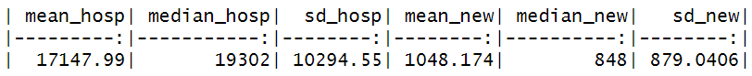
Mean_hosp | Median_hosp | Sd_hosp | Mean_new | median_new | Sd_new
17147.99 | 19302 | 10294.55 | 1048.174 | 848 | 879.0406

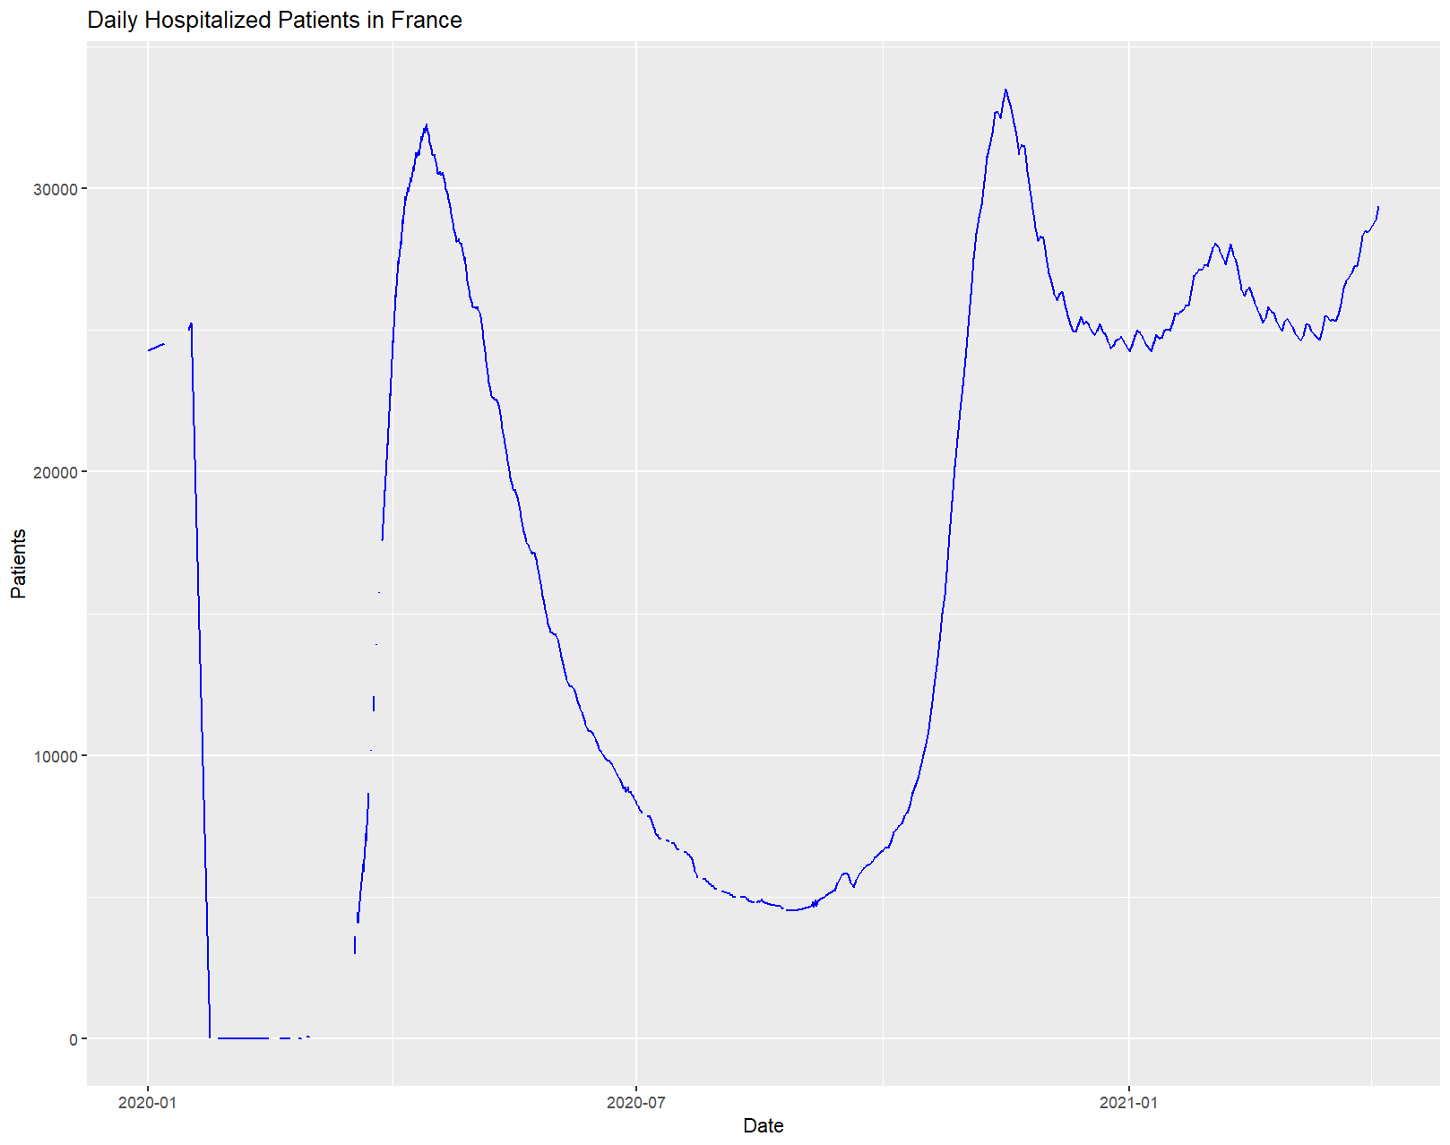
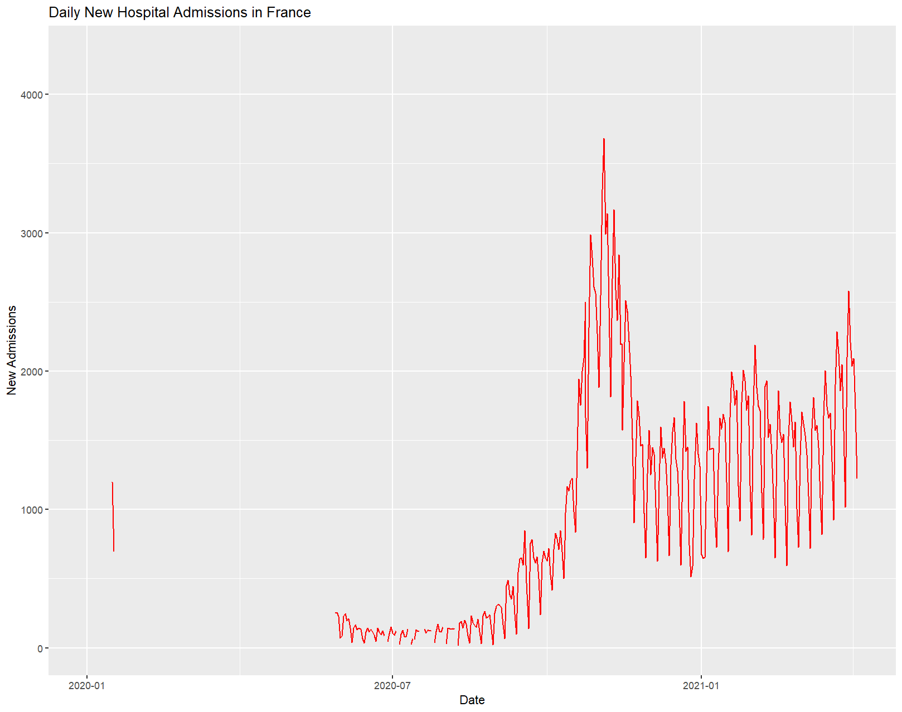
Statistical Methods
1. Confidence Interval for Average Hospital Burden
A one-sample t-based confidence interval was used to estimate the average number of hospitalized COVID-19 patients per day. This method is appropriate because:
- We are estimating the population mean using daily sample values
- The sampling distribution follows the CLT due to large sample size
- The t-distribution is applicable since population standard deviation is unknown
2. Pearson Correlation Analysis
A hypothesis test was conducted to determine whether new admissions are associated with total hospitalized patients.
Hypotheses:
H0: p = 0 (no linear relationship)
Ha: p ≠ 0
This method is appropriate because both variables are assumed to be continuous and measured over the same units (days).
3. Simple Linear Regression
A regression model was constructed: hospitalized = B0 + B1(new hospitalizations)
Purpose: To determine whether new admissions can statistically predict hospital occupancy.
Assumptions considered:
- Approximate linear relationship (validated visually)
- Independent daily observations (reasonable due to time-series spacing)
- Residual normality (not violated based on distribution shape)
Regression output includes:
- Slope estimate and significance
- Model fit index (R^2)
- Confidence intervals for coefficients
Results
Confidence interval
The mean daily number of hospitalized COVID-19 patients was x = 17,147.99 with a 95% CI of [16,413.47, 17,882.50]. This indicates that typical hospital burden during this time period was around 17,000 patients per day, with notable variability between surge periods.
Correlation Analysis
Pearson correlation results showed:
- r = 0.7015
- p < .001
- 95% CI = [0.66, 0.74]
Interpretation:
There is a statistically significant and strong positive association between daily new hospital admissions and total hospitalized patients. When new admissions increased, total hospital burden tended also to rise.
Regression Analysis
Model output: hospitalized=9536.49+7.82(new admissions)
Statistical results:
- B1 = 7.82, p < .001
- R^2 = 0.492
- F(1, 633) = 613.3, p < .001
Interpretation:
Each additional new admission corresponds to an estimated increase of approximately 8 hospitalized patients, likely reflecting delayed bed turnover. The model explains approximately 49% of the variability in hospital burden, which is large for public health surveillance data.
Confidence interval for slope: [7.20, 8.43] which confirms its significance.
Discussion
The results demonstrate that hospitalization trends in France during the pandemic followed clear wave-like patterns that reflect infection surges and subsequent hospital strain. Both correlation and regression results show that increases in new hospital admissions meaningfully predict overall hospital occupancy. This suggests that new admissions act as a leading indicator of health system burden, aligning with public health expectations.
The estimated confidence interval of hospitalizations reveals that daily hospital load was consistently high during most sampled months, with an estimated mean of over 17,000 patients. This implies persistent strain on French hospitals even outside extreme peak periods.
There are several limitations. First, the dataset is aggregated at the national level, preventing patient-level analysis or time to event modeling. Second, missingness early in the dataset may reduce accuracy during early months. Third, COVID-19 severity trends are influenced by confounders such as vaccination, clinical improvements, hospital discharge criteria, and socioeconomic variations, none of which were included here.
Conclusion
This statistical analysis indicates that new hospital admissions are strongly related to hospital occupancy and significantly predict future hospital demand. Hospital burden increased rapidly during major waves, highlighting potential strain points for health systems. These results demonstrate how basic statistical methods can reveal important pandemic dynamics using publicly available surveillance data. Future research may benefit from regional comparisons, modeling ICU-specific trends, and incorporating vaccination and mortality timelines.

References
mclikmb4. (2021). Coronavirus Dataset France. Kaggle.
https://www.kaggle.com/datasets/mclikmb4/coronavirusdataset-france

